Figure x.x: Fischertechnik Smart Factory

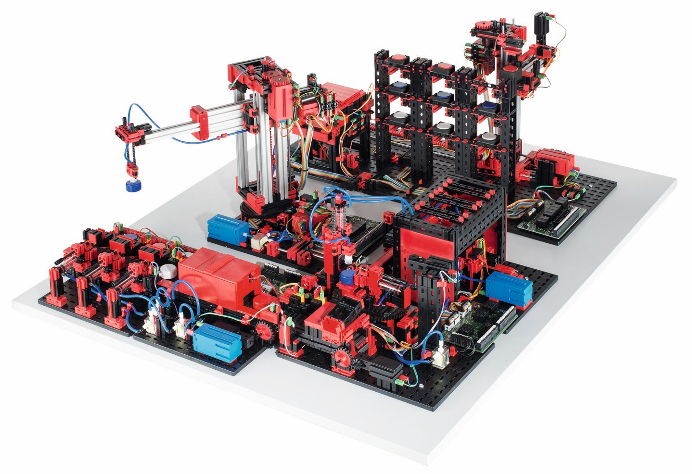

vacuum gripper robot

high-bay warehouse

sorting line with color detection

multi-processing station with oven

https://www.fischer.group/-/media/corporate/international/presse/images-presseinformationen/fischertechnik/2017/170926-fischertechnik-fabrik_simulation.ashx

The Fischertechnik Smart Factory is used in the project. It is a learning factory that comes with many features and in the following a typical process and how to keep track of the workpiece is described.

When the process is started, the transport arm of the high-bay warehouse (HBW) moves to the storage system, picks up the wanted workpiece and places it in the output station. There it is conveyed to the pick-up position of the vacuum suction pad. This process can be monitored with the end-switches of the transport arm and the light sensors of the output station. When the end-switch of the transport arm is released a workpiece is collected and when it is pressed again it is deployed to the output station. There two light sensors detect whether the workpiece is at the end or start of the conveyor belt.

The vacuum gripper robot (VGR) picks up the workpiece from the output station of the high-bay warehouse (HBW) and places it on the slide of the oven of the multi-processing station with oven(MPO). When the end-switch of the VGR is released this process has started and as soon as the light sensor of the slide is triggered the workpiece has reached the MPO. There the workpiece is pushed in, fired and moved out again. The transport carriage with vacuum suction pad then transports the workpiece to the milling machine. There, the workpiece is placed on the rotary table and when it the end-switch of it is pressed the MPO comes to its end.

After the milling process, the workpiece is pneumatically pushed onto the conveyor belt of the sorting line with color detection(SLD). On the conveyor belt, the workpiece passes through a color recognition system. Depending on the color detected, the workpiece is pneumatically pushed onto the corresponding chute. Once more the light sensors provide information of the status of the sorting line.

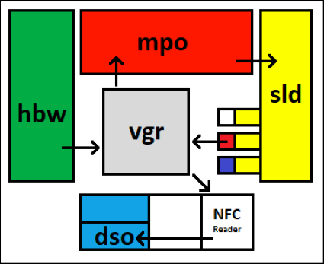

Figure x.x: Schematic plan of the Smart Factory

Table x.x: State of each station and the chutes

|  |  |  |  |
| --- | --- | --- | --- |
| Station | Sensor | State | Sensor value |
| High-bay warehouse | S1_I1 | Running | false |
| Inactive | true |
| Vacuum gripper robot | S2_I2 | Running | false |
| Inactive | true |
| Oven | S3_I6 | Running | true |
| Inactive | false |
| Milling machine | S3_I1 | Running | false |
| Inactive | true |
| White chute | S4_I4 | Full | false |
| Empty | true |
| Red chute | S4_I5 | Full | false |
| Empty | true |
| Blue chute | S4_I6 | Full | false |
| Empty | true |

The Smart factory is connected to a PLC from Beckhoff and controlled with their software TwinCAT 3. The input and output data od the sensors and actuators has to be written into a server to make it available for the arcstone MES.